Nate Riggs
CS-340
Southern New Hampshire University
04/18/2025
Project Two README

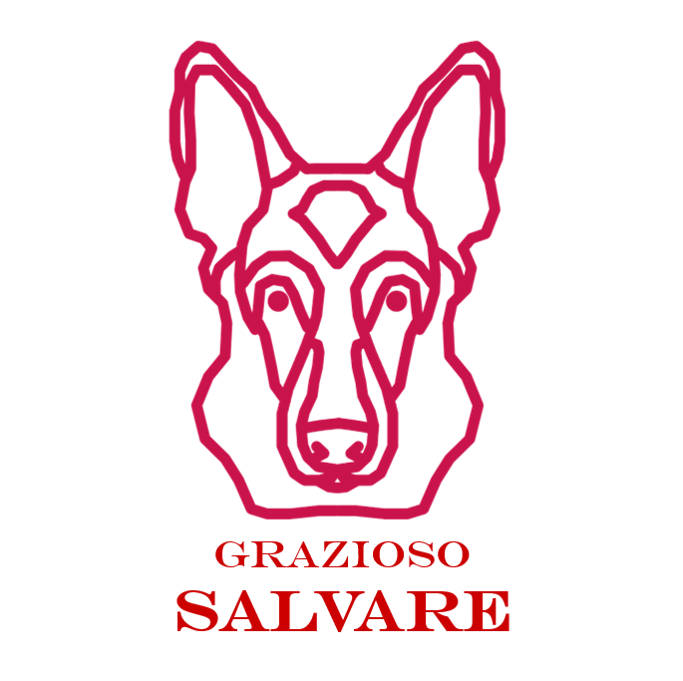

GRAZIOSO SALVARE DASHBOARD

Project Description
The Grazioso Salvare Dashboard is an interactive web application that allows the user to interact with animal outcomes from the Austin Animal Center. The application allows the user to filter the data table depending on the rescue type and see what specific animals are best for those purposes. The dashboard includes various options that will allow user to interact with the dashboard such as filtering and sorting. The dashboard also includes a geolocation chart that will display the location of a selected animal as well as a pie chart that will display the highest number of breeds available depending on the filter selected.

Steps to Reproduce
- Using user with proper privileges, import necessary CSV file into MongoDB
- Ensure that ProjectTwoDashboard.ipynb file and CRUD.py files are in same working directory
- Once CSV is imported, open ProjectTwoDashboard.ipynb file
- Update username and password variables to proper user and password
- Run file and a URL will be provided
- Either click directly on link or copy/paste URL into a new browser window which will direct you to the Project Dashboard
- Once dashboard has loaded, user is able to interact with the dashboard and perform tasks such as enable filters and sort items. Users can also select an entry and have its location displayed on a map

Tools Used
- Python
  - Used for scripting and data manipulation
- Dash
  - Framework for building web applications
  - Dash is a framework that provides both the view and controller structure for web applications. It uses HTML and interactive components defined in Python to create the view. Dash uses callback functions that connect user inputs to the application logic to update the view based on user interactions.
- MongoDB
  - Database software used for storing and retrieving animal data
  - MongoDB was used due to its flexibility with handling unstructured data. Its BSON format maps easily to Python dictionaries, and libraries like PyMongo offer straightforward, efficient integration, making data modeling and querying seamless
- Plotly
  - Used for creating interactive charts and graphs
Steps Taken
- Set up MongoDB and Python environment
- Using valid user credentials, import the CSV into MongoDB to allow for CRUD operations
- Develop CRUD operations to allow user to interact with database using CRUD.py file
- Build Dashboard Layout
  - Created a datatable with interactive filters and sorting
  - Implemented various charts and graphs
- Implement Callbacks
  - Added more interactivity to the dashboard and allowed users to update charts and the data table itself based on animal selection and filters
- Testing and Debugging
  - Ensured all components worked as expected and all requirements were met
Challenges
- When the dashboard would initially be displayed, numerous errors would appear stating that a “None type object” was not iterable. This error was coming because the data frame was trying to be iterated over before any data was imported. I implemented a check to check if the data frame was empty and, if it was empty, it would not attempt to iterate to display any information and would just continue execution of the program and that solved the issue of those errors appearing.
- The next challenge that I overcame was in regards to the Pie Chart that I implemented. When I first implemented the chart, without making any changes to what data was displayed, there were too many pie slices and it made the chart hard to read and look sloppy. I fixed this by determining what five breeds had the highest number of entries in the database, display those breeds, and then total up all of the other breeds and display that as “Other”. In order to ensure that it would only do that when a filter wasn’t selected, I created a series of if/else statements to check what filter was in place. If the “Reset” filter was in place, it would count the breeds with the highest number of animals in the database and then group all of the others together as “Other”.

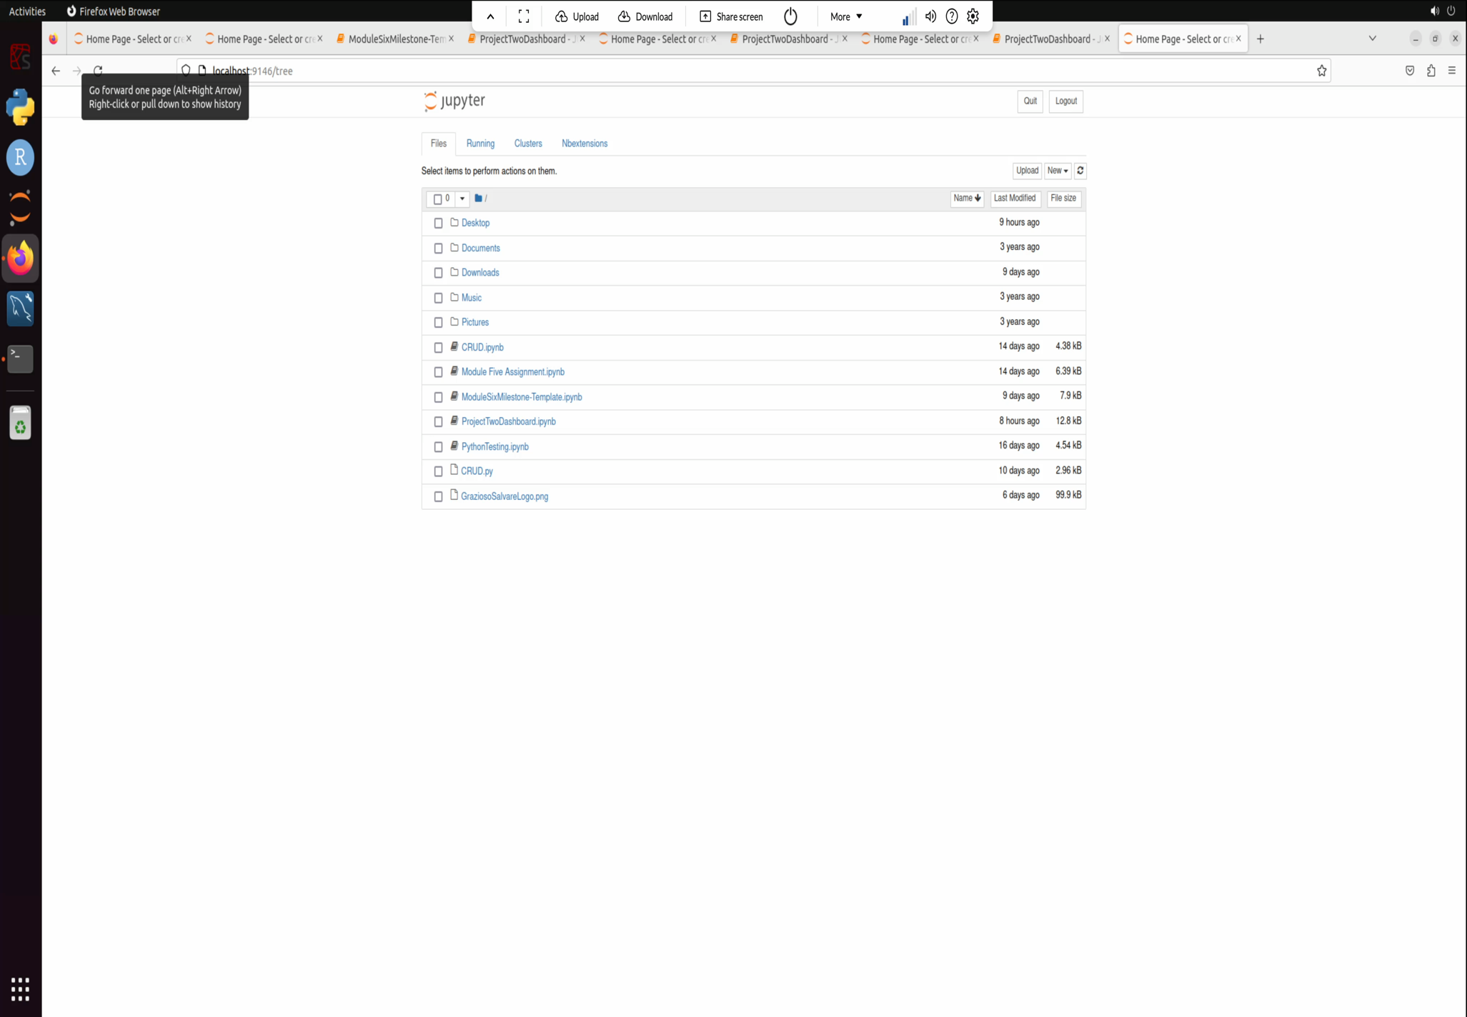
Screen Recording of Functionality

